VEX IQ Level Up: Session 3 - Driving Test
Activity: Drive under one wall structure and then around the other.

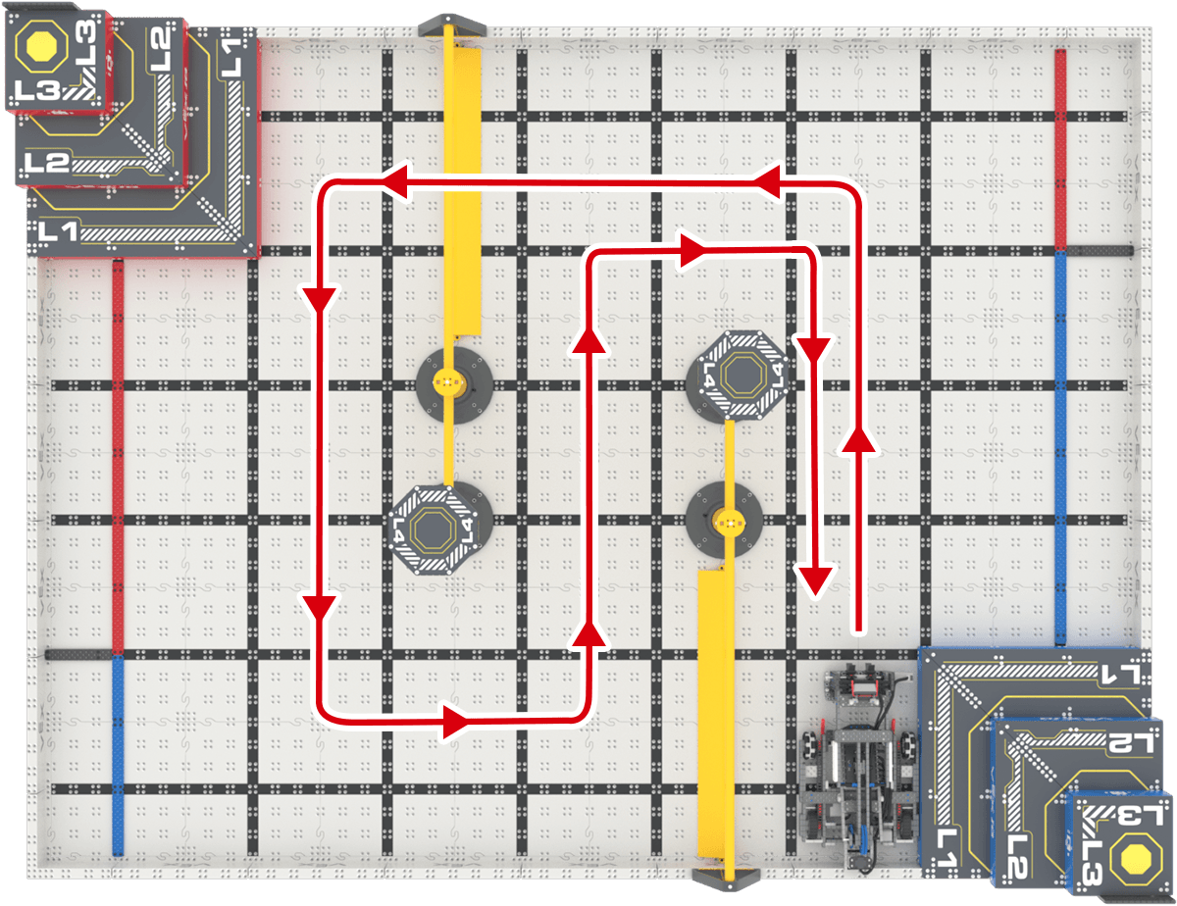
- Set up for the activity:
  - Make sure the Controller is paired with the robot. Use the information in this article to help you.
  - Set up your field as shown in the image to the right.
  - Start the Drive program on the VEX IQ Brain.
- You will test all four configurations and see how long it takes to drive under one wall structure and then around the other.
  - Time how long it takes to complete the drive path.
  - Record your time and any other notes about the task in your engineering notebook.
- Place Flop back into the same starting position and orientation against the bottom Field wall. Repeat the test with each of the drive configurations.
  - Record the time and notes for each driver configuration.

Example Documentation: On the following page.
Remember, this is just one way to document your data. Document in the way that works best for you!

Feeling Stuck? Slow down and practice driving forward, backward, left, and right before beginning the task. Maybe this Drive Configuration isn’t for you. You will also improve over time!

Helpful Tip: If Flop gets stuck between a Pyramid Goal and a Floor barrier, or on another obstacle, try raising the arm slightly (using the F buttons on the controller). This can make it easier to move around tight spaces.

Discussion Questions  - What do you like about each drive mode?  - What do you dislike?  - How can you improve your driving or documentation skills? | Activity Checklist  - Each team member drove the drive path with all four configurations.  - Each team member recorded drive data in the engineering notebook.

Example Documentation

Remember, this is just one way to document your data. Document in the way that works best for you!
Task: Drive under one wall structure and then around the other!

Driver | Configuration | Joystick Controls | Time
Lauren | Tank Drive | 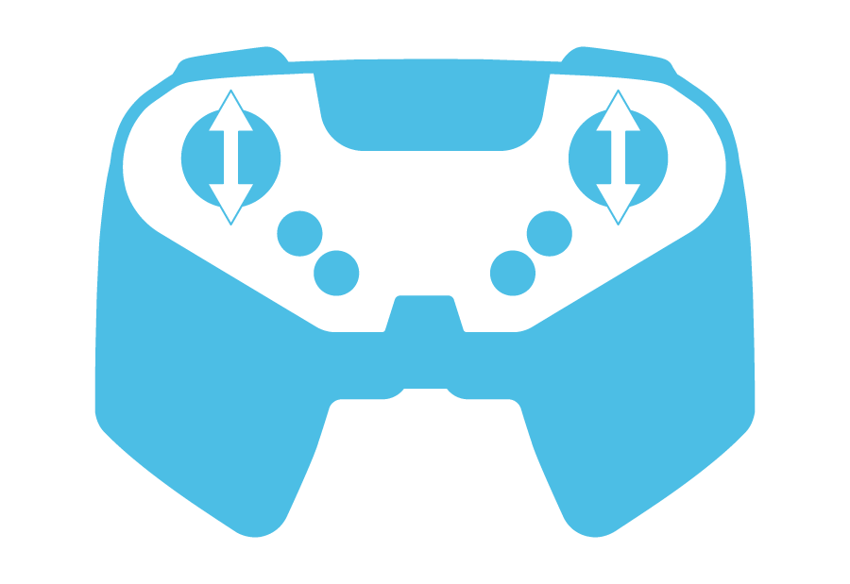  Left motor with left joystick  Right motor with right joystick | 39 seconds
Lauren | Notes:
Lauren | Left Arcade
Lauren | Notes:
Lauren | Right Arcade
Lauren | Notes:
Lauren | Split Arcade
Lauren | Notes:

